AI-Chat-Bot

Module : Artificial Intelligence (AI)
Student Name :
Registration No :
Assignment no : 002
Date Submitted : 07/05/2026

Table of Contents
Table of Contents 2
List of Figures 6
List of Tables 7
Acknowledgement 8
1. Executive Summary 9
2. Methodology and Development Lifecycle 9
3. Introduction 10
3.1. Project Background 10
3.2. Objectives and Goals 10
4. Problem Domain and Motivation 11
4.1. Problem Statement 11
4.2. Problem Solution 12
4.3. Selected Domain Analysis 12
4.4. Motivation for AI Integration 13
5. System Requirements Analysis 13
5.1. Functional Requirements 13
5.2. Non-Functional Requirements 14
6. Feasibility and Toolchain Analysis 15
6.1. Project Scope 15
6.2. Technical Feasibility 15
6.3. Economic Feasibility 16
6.4. Schedule Feasibility 16
6.5. Market Feasibility 17
6.6. Operational Feasibility 17
6.7. Legal and Regulatory Feasibility 17
6.8. Risk Analysis 18
5.8.1. Potential Obstacles 18
6.8.2. Mitigations (SWOT Analysis) 18
7. High-Level Three-Tier Architecture 21
7.1. Architecture Diagram (NLI, Inference Engine, Knowledge Base). 21
7.2. Data Path and Communication Flow (From GUI input to DB retrieval) 22
7.3. Use Case Diagram 23
Actor 1: The Guest User 24
Actor 2: The Registered User 24
7.4. Class Diagram 24
8. Natural Language Interface (NLI) Design 25
8.1. UI/UX Design (Frame-switching architecture using HTML/CSS) 25
8.1.1. Initial Guest Portal 26
8.1.2. User Authentication Gateway 27
8.1.3. Account Registration Interface 28
8.1.4. Authenticated Dashboard View 29
8.1.5. Interactive Reservation Workflow (Step 1) 30
6. Interactive Reservation Workflow (Step 2) 31
8.2. Text Processing and Normalization 31
9. Inference Engine Reasoning and Processing 32
9.1. Pattern Matching and Intent Recognition (PyTorch Neural Network) 32
9.1.1. Neural Network Architecture 32
9.1.2. NLP Pre-processing Pipeline 33
9.1.3. Intent Tagging 33
9.2. Confidence Thresholds & Routing Logic 33
9.2.1. Routing Decisions 33
10. Knowledge Base and Database Integration 34
10.1. Static Knowledge Management 34
10.2. Dynamic Data Retrieval 34
10.2.1. Core Database Tables using dynamic data retrieval 34
10.2.2. Data Access Logic 35
10.2.3. Intelligent Routing 35
11. Machine Learning and Adaptive Training 35
11.1. Self-Learning Mechanism 35
11.1.1. Fallback Logic & Learning Trigger 36
11.1.2. Capturing User-Supplied Answers 36
11.2. Fuzzy Fact Retrieval 36
11.2.1. Resilient Q&A Matching 36
11.2.2. Fuzzy Package Resolution 37
12. Data Modeling and Schema Design 37
12.1. Database Tables and Relations 37
12.2. Physical and Logical Schema. 38
12.2.1. Logical Schema 39
12.2.2. Physical Schema 39
13. Conversation and Dialogue Management 39
13.1. Dialogue State Tracking (The Multi-Step State Machine) 40
13.1.1. Linear and Non-Linear Changes 40
13.2. Input validation (Regex and Dynamic Constraints) 40
13.2.1. Hard Validation (Pattern Matching) 40
13.2.3. The Rejection Loop 41
14. Security and Privacy Protocols 41
14.1. User Authentication 42
14.1.1. JSON Web Token (JWT) Implementation 42
14.1.2. Authentication Logic 42
14.2. Data Encryption 42
14.2.1. Bcrypt Password Hashing 42
15. Testing and Performance Benchmarking 43
15.1. Accuracy and Recall Testing (Intent Prediction) 43
15.2. Validation & Error Handling 44
15.3. Unit Testing 46
15.4. System Testing 47
16. User Manual and Operational Guide 48
16.1. Installation and Setup 48
16.1.1 System Requirements 48
16.2. User Interaction Flow 50
16.2.1. Launching the Application 50
16.2.2. Guest Browsing vs authenticated booking 50
16.2.3. Learning Hub Interaction 51
16.2.4. UI Customization and Exit 51
17. Individual Contribution Report 51
18. Future enhancements and scalability 52
18.1. Technical & AI Enhancements 52
16.2. Functional & Feature Upgrades 52
16.3. Scalability & Infrastructure 53
References 1

List of Figures
Figure 1: Class Diagram 24
Figure 2: Initial Guest Portal 26
Figure 3: User Authentication Gateway 27
Figure 4: Account Registration Interface 28
Figure 5: Authenticated Dashboard View 29
Figure 6: Interactive Reservation Workflow (Step 1) 30
Figure 7: Interactive Reservation Workflow (Step 2) 31

List of Tables
Table 1: Confidence Thresholds & Routing Logic 22
Table 2: Data Access Logics 24
Table 3: Database Tables & Relationships 26
Table 4: Intent Prediction Performance Testing 32
Table 5: Validation & Error Handling Testing 33
Table 6: Unit Testing 35
Table 7: System Testing 36

Acknowledgement
The completion of this project is credited to the support and guidance provided by several key individuals and academic bodies.

Significant gratitude is extended to Mr. Chameen, the Artificial Intelligence module lecturer, for the essential technical guidance and academic mentorship provided throughout the development process. Appreciation is also directed toward the lecturer panel and the administrative staff at ESOFT Metro Campus for maintaining a supportive educational environment and providing necessary resources.

Furthermore, the academic standards and curriculum framework established by London Metropolitan University served as the foundation for the professional competencies applied in this work.

1. Executive Summary
This document provides a comprehensive technical and operational overview of Nexus, an intelligent conversational virtual assistant designed to streamline the tourism and booking experience in Sri Lanka. It details the project’s lifecycle, beginning with a Problem Domain Analysis that identifies current inefficiencies in manual travel coordination and continues through a rigorous Feasibility and Toolchain Study. The report encompasses the system's High-Level Three-Tier Architecture, illustrating the integration between a responsive web-based Natural Language Interface (NLI), a PyTorch-driven Inference Engine, and a structured SQLite Knowledge Base.

Furthermore, the document covers extensive design and implementation specifics, including UI/UX frame-switching logic, text normalization pipelines, and a sophisticated self-learning mechanism that allows the bot to adapt to unknown queries. Security protocols, such as Bcrypt password hashing and JWT session management, are documented alongside a full suite of Accuracy, Unit, and System Testing results to verify platform reliability. Finally, the report concludes with a User Manual for deployment and a roadmap for Future Enhancements, such as LLM integration and real-time payment processing, to ensure the system’s long-term scalability and market relevance.

2. Methodology and Development Lifecycle
The successful realization of the Nexus chatbot relies on a structured Software Development Life Cycle (SDLC), prioritizing modularity and iterative refinement to ensure the AI components align with business logic. This methodology provides the blueprint for how the system’s technical requirements are transformed into a functional assistant. The project follows a modular development strategy, allowing for the independent engineering of the NLP engine, the database schema, and the user interface. By separating the application into these distinct modules, the team ensures that updates to the AI model (such as retraining the neural network) do not disrupt the core database or the visual frontend.

3. Introduction

3.1. Project Background
The travel industry has developed rapidly and while it is great to have so many options to choose from, it can still be stressful and time-consuming for the customer to plan a trip. A traveler has to spend hours scouring the various websites to get all the information about a tour package, its cost and the schedule. Recently, Artificial Intelligence (AI) has started to change how the travel industry operates. By enabling travel firms to engage in real-time interactions with customers, conversational AI, including smart chatbots, empowers them to interact with customers around the clock without requiring constant human presence. A customer can ask a chatbot for information about a tour, and obtain a prompt, accurate response without waiting days to receive an email. A tourist-friendly location such as Sri Lanka could surely benefit from having a modern digital assistant that can automatically respond to questions and make bookings. This project proposes a smart virtual travel assistant “Nexus”, specifically for Sri Lanka tourism to eliminate these delays and enhance the customer experience.

3.2. Objectives and Goals
The main objective of this project is to develop an intelligent, text-based virtual assistant that makes travel planning easy and interactive. To achieve this, the project focuses on five specific goals.
- The system aims to understand natural human language accurately. It uses a PyTorch machine learning model to read a user's typed message and figure out exactly what they are asking whether it is about a tour price or a travel itinerary.
- The project focuses on automating the booking process. The bot is designed to guide the user step-by-step through a friendly conversation to collect their travel details, replacing the need for traditional, static web forms.
- The project aims to provide secure and personalized experience. It includes an authentication system where users can register and log in. Once logged in, the system securely remembers their details, allowing them to book tours seamlessly.
- A major goal of this project is to implement a “self-learning” capability. If the chatbot does not know the answer to a specific user question, it will safely ask the user for the correct information, save that new fact to the database, and use it to help future travelers.
- The project aims to deliver a highly engaging and customizable User Experience (UX). This includes implementing a modern, responsive interface with dynamic response styling, user-controlled theme settings, and pre-defined suggestion chips to guide the conversation. Additionally, the bot is equipped with conversational “small talk” capabilities and chat history retention to make interactions feel more natural and human-like.

4. Problem Domain and Motivation
The problem domain is used to refer to the particular area of expertise or real-world environment that a software system is created to solve. The definition of this domain is an important step in the development of the system as it will help identify the boundaries of the system, as well as the specific needs of people who will use it. In the context of modern software development, this includes the consideration of how human activities and business workflows can be enhanced with the help of digital tools and improved data management.

Through studying the domain, the developers are able to comprehend the rules, processes and issues that exist within a given industry. Such analysis will make sure that the end product is not only technically viable but also offers a viable solution to the current challenges. This theoretical background enables a more systematic approach to the construction of features which are relevant to the target environment and provides a clear framework into which the technical implementation that follows can be situated (Ivanov and Webster, 2019).

4.1. Problem Statement
Managing customer communication and service delivery has become a big challenge in the tourism industry in Sri Lanka. The time zone differences that make email replies by local agencies to take long queues is a problem facing international travelers. Since most of the agencies use human personnel to respond to recurrent queries about prices, schedules and group size, they cannot provide 24/7 services. This is not an immediate response, which results in a low-quality customer experience and makes potential tourists cancel their bookings. Moreover, the standard websites utilize stagnant forms and naive FAQ pages that are not only dull and uninspiring, but also unimaginatively designed, with the layouts being awful and unattractive, not to mention that they are so unsightly that they virtually cause eye discomfort. These systems cannot accept unique or complex questions posed by users. Losing business opportunities to other countries with more technologically advanced competitors, without a modern digital assistant, travel agencies continue to lose business opportunities.

4.2. Problem Solution
Nexus virtual travel assistant is aimed at eliminating these problems through offering an intelligent and automated communication platform. This solution would resolve the problems identified based on a few important aspects.

- The chatbot is available 24/7 to make sure that no matter what time zone a global traveler is in, he or she will get instant answers.

- The system can recognize natural human language and return the relevant information about the tour packages and itineraries as soon as it is typed.

- The bot replaces the traditional web forms with an interactive, friendly conversation booking form that is more natural to the user.

- The system supports a secure log-in system, which stores user information to enable the booking process to be quicker and more personal.

- The bot has a special self-education system that enables the robot to expand its knowledge by seeking and storing new information whenever the robot faces a question that it cannot answer.

- The responsive, modern user experience leverages suggestion chips and theme settings to make the travel planning process interesting and user friendly.

- The solution will ease the workload of human agents, since routines are automated, and human agents are able to concentrate on more complex customer needs.

4.3. Selected Domain Analysis
Sri Lanka is a highly popular travel destination known for its rich cultural heritage, wildlife safaris, and beautiful beaches. However, planning a trip to Sri Lanka can be a frustrating experience for international tourists. Visitors often face challenges such as time zone differences, delayed email responses, and scattered information across different agency websites. For local travel agencies, managing customer inquiries is equally difficult. Human agents are frequently overwhelmed by repetitive questions about tour prices, daily itineraries, and group size limitations. When human agents are unavailable after working hours, potential customers are left waiting, which often leads to abandoned bookings and lost business. The Sri Lankan tourism sector needs a digital solution that can provide instant, accurate information to global travelers at any time of the day.

4.4. Motivation for AI Integration
The primary motivation for integrating Artificial Intelligence into this domain is to completely automate routine customer service tasks while maintaining a natural, friendly conversation. Standard web forms and FAQ pages are often too rigid and boring for users. By using Natural Language Processing (NLP), the “Nexus” chatbot allows users to ask questions in their own words and receive instant, personalized answers. Furthermore, a major motivation for this project is the implementation of adaptive self-learning. Traditional chatbots fail when they are asked a question, they were not originally programmed to answer. By integrating a self-learning mechanism, Nexus can identify what it does not know, safely ask for the correct information, and store that new knowledge for future interactions. This creates a highly sustainable system that continuously improves over time, significantly reducing the workload on human travel agents while providing a superior booking experience for tourists.

5. System Requirements Analysis
The process of analysis of system requirements is a very crucial stage in the software development process where the specific requirements and constraints of the software are identified and defined. This stage is to make sure that the end-product is in accordance with the desired operation of delivering an automated travel assistant. In this project, the requirements gathering was conducted by thorough examination of the current digital travel platforms and analyzing the common user issues in the tourism industry. The features that are needed to develop a more efficient and interactive experience were determined by studying how travelers interrelate with online booking systems. This ultimately enabled the setting of clear technical boundaries without necessarily requiring external consultations but rather focusing on industry standards and the capability of the modern software.

Complex software systems cannot be constructed without a solid foundation created by requirements analysis. Developers can come up with a roadmap that will be used to minimize errors during the actual coding phase. This systematic methodology can assist in systematizing the development work and ensure that each feature to be added to the bot has a particular purpose to the final user (Sommerville, 2016).

5.1. Functional Requirements
The functional requirements outline the tasks and services that the Nexus chatbot will have to offer to the users. These requirements are concerned with the fundamental functions of the system.
- The system should have a machine learning model to handle natural language and determine the intent of a message being posted by a user.
- The bot should be capable of giving the correct information about offered tour packages, company information and travel itineraries when requested.
- There should be a secure user authentication system that will enable new users to register and existing users to log in to their accounts.
- The system will have to handle an interactive booking system that uses a conversation to lead the user through a conversation to gather both the travel dates and the group sizes.
- The software should be smart enough to recognize when someone is logged-in and automatically leave questions concerning names or email addresses out during a booking.
- The system should have the feature of self-learning whereby the system would inquire the user to provide the information when the question is not identified.
- It means that the backend needs to store all the newly acquired facts in a local database to be utilized to answer future questions.
- The application should produce structured data to enable the frontend to show rich visual contents such as tour cards and tour summaries.

5.2. Non-Functional Requirements
Non-functional requirements are used to specify the quality characteristics and the operational limits of the system. These standards guarantee that the Nexus chatbot is not just useful, but also safe, effective and sustainable.
- Performance: The inference engine of the PyTorch should be able to process user input and generate conversational response within less than one second, a speed that will keep the natural speed of conversation.
- Data Security: The system should be highly secured by encrypting all user passwords with the Bcrypt library before they are stored in the database.
- Session Management: User communication should be securely handled by using JSON Web Tokens that will safeguard personal information and keep a session active.
- Usability: The frontend should be created as Single Page Application to enable smooth user experience without the necessity to reload the page constantly.
- Responsiveness: The user interface would have to be completely responsive and that the layout would automatically adjust depending on the screen size and the device used, using the latest styling applications.
- Visual Consistency: The application should have a professional dark appearance and be consistent throughout all parts of the user interface.
- Maintainability: The codebase has to adhere to a modular architecture to ensure that the database logic, backend controller and frontend components are entirely separated so that they can be updated easily.
- Reliability: The system should be able to manage any unexpected inputs or errors in the graceful manner to ensure that the application does not crash because of any error.

6. Feasibility and Toolchain Analysis
Feasibility analysis is a serious analytical stage that defines whether a project can be successfully achieved based on the available technology, budget and time. This paper examines the various factors that may influence the development of Nexus chatbot and makes sure that the project is viable and sustainable. The team can test the compatibility of the choice of technologies and whether it can provide the necessary features required. Organized feasibility study helps in revealing the risk that may be encountered early in the development cycle so that the team may make informed decisions that will be in line with the overall project objectives (Whitten and Bentley, 2005).

6.1. Project Scope
The scope of the Nexus project will involve the end-to-end development and deployment of a standalone conversational AI system to suit the Sri Lankan tourism market. It entails training and designing a specialized Natural Language Processing (NLP) model to classify user queries in the field of travel correctly. The project involves architectural realization of a conversational logic layer that interposes between fixed data entry and dynamic, guided dialogue flow to manage tours. Also, it is expanded to develop a secure user management system, including encrypted authentication and session management to guarantee integrity of data. One of the technical limits of this project is the incorporation of an adaptive knowledge acquisition module, which will make this system expand its database by way of real-time user interactions. Lastly, the scope includes the engineering of a responsive, web-based graphical interface and final packaging of these components into a single, desktop executable to ensure high accessibility and performance to local travel agencies.

6.2. Technical Feasibility
The Nexus chatbot has very high technical feasibility since the project will be utilizing open-source technologies which are largely reliable and well supported.

- Python is the main language of choice since it offers powerful libraries of both the machine learning elements and the logic behind the machine learning.
- The NLP model is developed using PyTorch and will ensure the chatbot is able to detect human language and answer it with a high level of accuracy.
- The developers of this AI Bot have selected the Eel library to provide the connection between the Python back-end and a web based front-end, allowing a much more modern design than a traditional GUI library.

- Application development with HTML, JavaScript, and Tailwind CSS is extremely feasible to create a responsive Single Page Application.
- SQLite, a lightweight and serverless database, manages data handling: it is ideally suited to a local desktop environment.

6.3. Economic Feasibility
Financially the project is very feasible because it does not need a huge budget or even costly resources.

- All the software tools and programming libraries used in this project, such as Python and PyTorch, are free and open source.
- One does not incur software licenses, or subscription fees to develop and operate the application.
- The system is intended to be run locally on the hardware of the user, which implies that there is no need to use expensive cloud hosting or server maintenance.
- The development process does not require purchasing special high-end hardware, as standard personal computers can be used to complete the development.

6.4. Schedule Feasibility
The project is expected to be accomplished in an effective split of work between the team of developers related to this project.

- The development tasks are broken down into transparent modules, including backend logic, AI training, and frontend design, which enables them to work simultaneously.
- Modular architecture implies that the various components of the system can be independently tested and then assembled.
- The team will be able to meet the deadlines of the project proposal, software development and final demonstration by following a structured plan.
- The fact that simple to use libraries such as Eel and Tailwind CSS are used to accelerate the process of development to a great extent.

6.5. Market Feasibility
Market feasibility is concerned with whether the product is needed by the target market in Sri Lanka, and whether the product will be of value to the target market in Sri Lanka.

- The Sri Lankan tourism business is a significant component of the national economy and there is a great need to invest in the digital tools that can enhance customer service.
- This unique issue is solved by addressing the common issue of time zone difference between international travelers and local agencies.
- The self-learning system creates a competitive edge because the bot gets smarter and useful as it is not manually updated every time.
- Responsive and professional design makes the tool appealing to the local travel agencies that would like to upgrade their booking systems without necessarily incurring high costs.

6.6. Operational Feasibility
Operational feasibility looks at the compatibility of the Nexus chatbot to the daily operations of the tourism sector, and how easy users can be integrated with the system.

- The system is also made highly user-friendly such that even travelers with minimal digital literacy would be able to communicate with the bot without having to undergo any technical training.
- Automation of routine inquiries means that the operational load on the staff of travel agencies is reduced, and the staff can focus on high-value work, leaving the initial contact with the customer to the bot.
- The bot offers 24/7 services, thus ensuring business continuity about international time differences.
- The self-learning feature will ensure that the system will always stay relevant over time as it will automatically update to the type of question asked by the tourists.

6.7. Legal and Regulatory Feasibility
The analysis will be used to ensure that the project meets the required legal requirements and data protection laws that will apply in software development and tourism.

- The project also complies with data privacy principles, as the personal user data, including names and travel details, is stored securely in a local database.
- Since the application is an encryption library of passwords and session tokens, the application satisfies the basic security requirements in safeguarding user authentication data.
- The project is based on open-source software and permissively licensed libraries so that there are no legal concerns about copyright or intellectual property.
- The practices involved in the development of the AI-based bot are guided by the standard ethical guidelines to Artificial Intelligence, namely, by making the bot transparent as it needs to request the user to provide new information.

6.8. Risk Analysis

5.8.1. Potential Obstacles
In the process of creating and implementing Nexus chatbot, several issues might emerge that can affect the success of the project.

- Intent Misclassification: The machine learning model may have a hard time interpreting either very complex or ill phrased user questions and therefore responds incorrectly.
- Database Locking: SQLite is used, which means that simultaneous operations with the database by the bot and a database viewer may cause temporary access problems.
- The Accuracy of Data in Learning: When a user inputs the wrong information during the self-learning process, the bot may store and revisit the misleading facts to other users.
- Hardware Compatibility: Disparities in local computer setup might result in unforeseen conduct when the Python-based executable is executed on other computers.

6.8.2. Mitigations (SWOT Analysis)
To overcome these challenges, a SWOT analysis is employed to determine how weaknesses and threats can be overcome by taking advantage of internal strengths and external opportunities.

Strengths

- Modular architecture enables the AI model to be easily tested and refined to enhance intent recognition.

- A high degree of built-in security is offered by using industry-standard encryption of user accounts.

Weaknesses

- The use of a single-file database such as SQLite constrains the capacity of the system to support huge volumes of simultaneous data transfer.

- The existing model is restricted to English that might not allow users who use other languages that are widely used in the tourism industry.

Opportunities

- The increasing popularity of the Sri Lankan tourism gives a huge market in testing and expanding the knowledge base of this bot.

- The project can be revised in the future to feature more developed AI models as the open-source technology will keep on developing.

Threats

- The fast pace of web technologies may necessitate periodic updates to the frontend styling and to the Eel library bridge.

- Un-corrected errors by the user when learning could hurt the credibility of the information provided by the bot unless monitored.

6.9. Toolchain Analysis

The Nexus toolchain operates as a streamlined, high-velocity assembly line, pivoting away from rigid compiled structures to embrace the fluid, interpreted power of Python within the Visual Studio Code environment. At the vanguard of this architecture sits the Natural Language Interface (NLI), a sophisticated processing gate that deconstructs raw user input into manageable semantic structures, ensuring the bot perceives intent rather than just syntax. This interpreted stream flows directly into the Inference Engine, the project's intellectual core, which utilizes a modular logic framework to cross-reference user queries against a live Knowledge Base. By leveraging Python’s expansive library ecosystem, the toolchain facilitates a rapid “code-test-deploy” cycle, allowing for real-time adjustments to the bot's reasoning patterns without the overhead of heavy architectural boilerplate. Beneath this cognitive surface lies a robust data persistence layer powered by SQLite, chosen for its zero-configuration efficiency and seamless integration with Python's standard database interfaces. The toolchain orchestrates a rhythmic exchange between the LearnedFacts module which captures and serializes new information on the fly and the core relational tables governing Users, Bookings, and TourPackages. Instead of a traditional controller-heavy approach, the system utilizes a lightweight, functional pipeline where data is transformed and validated through specialized Python scripts, ensuring that every interaction remains performant and thread-safe. This synergy creates a “living” toolchain where the boundary between static code and dynamic learning is blurred, resulting in an AI assistant that scales its intelligence alongside its database.

7. High-Level Three-Tier Architecture

7.1. Architecture Diagram (NLI, Inference Engine, Knowledge Base).
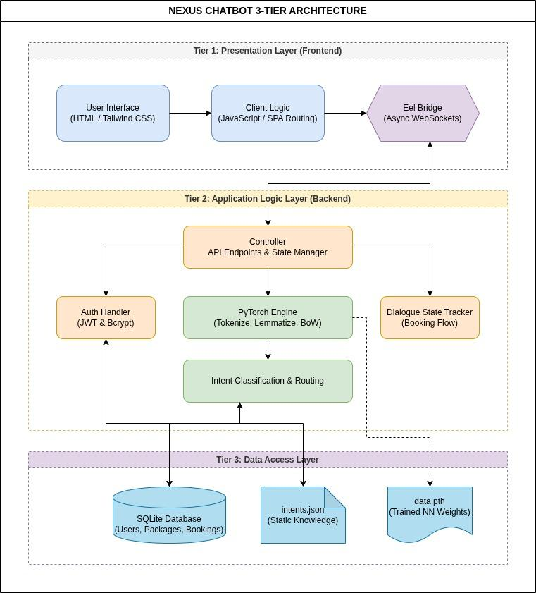The Nexus chatbot is built using a modern, decoupled three-tier architecture, which separates the user interface from the backend logic and the database. The Presentation Layer (Tier 1) is responsible for the visual experience. It is built using HTML, Tailwind CSS, and JavaScript, providing a fully responsive Single Page Application (SPA) that communicates with the backend via the asynchronous “Eel” bridge. The Application Logic Layer (Tier 2) acts as the brain of the system. Written in Python, it contains the main controller, the secure authentication handlers (JWT and Bcrypt), the multi-step booking state machine, and the PyTorch Natural Language Processing (NLP) engine. Finally, the Data Access Layer (Tier 3) functions as the system's memory. It consists of an SQLite relational database for storing dynamic records (like user profiles and tour packages), a data.pth file for the trained neural network weights, and an intents.json file for static conversational knowledge.

7.2. Data Path and Communication Flow (From GUI input to DB retrieval)
The communication flow of the system is designed to be seamless and instantaneous. The process begins when a user types a message into the frontend chat interface. The client-side JavaScript captures this text, packages it along with the user's secure session token (if logged in) and sends it to the backend using the Eel asynchronous bridge.
Once the data reaches the backend, the controller.py file takes over. It first checks the user's dialogue state. For example, if the user is currently in the middle of the booking process, the controller bypasses the AI and routes the text directly to the booking state machine to validate their input (like a phone number or travel date). However, if it is a standard conversational message, the text is sent to the PyTorch NLP engine. The engine tokenizes the sentence, converts it into a “Bag-of-Words” vector, and predicts the user's intent with a specific confidence score.
After the intent is classified, the routing logic triggers the appropriate data handler. If the user asks about tour limitations or packages, the backend executes an SQL query to retrieve that specific information from the SQLite database. Instead of generating a plain text reply, the backend formats this retrieved data into a structured JSON object. This JSON response is sent back across the Eel bridge to the frontend. Finally, JavaScript reads the JSON data types and dynamically renders beautiful, styled Tailwind CSS components, such as a rich information card or a booking summary, directly onto the user's screen.

7.3. Use Case Diagram
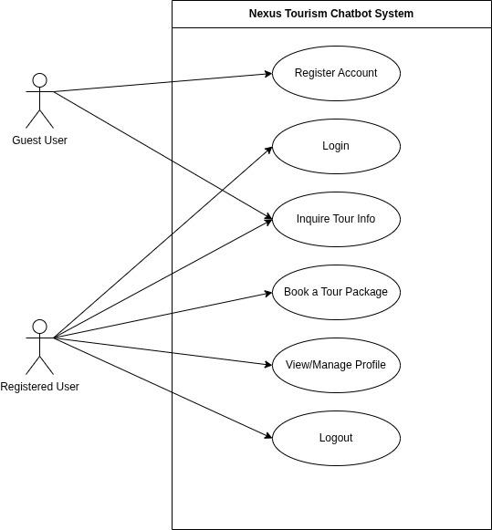

A Use Case Diagram provides a high-level visual representation of how different users interact with the Nexus chatbot system. It maps out the main actors (users) and the specific actions, or “use cases,” they are authorized to perform. For this system, the interactions are divided between two primary actors: the Guest User and the Registered User.

Actor 1: The Guest User
The Guest User represents any visitor who opens the chatbot without logging into an account. The system allows the Guest User to perform basic, non-sensitive tasks. Their primary use case is “Inquire Tour Info,” which allows them to chat with the AI to ask questions about Sri Lanka travel packages, itineraries, pricing, and general company details. However, if a Guest User decides they want to reserve a trip, the chatbot will prompt them to use the “Register Account” use case. This function allows the guest to securely input their first name, last name, email, and password to create a new profile in the database.

Actor 2: The Registered User
The Registered User is an individual who has successfully created an account and logged into the system. This actor inherits the same ability to “Inquire Tour Info” as the Guest User, but they also unlock several secure, personalized actions. They begin by using the “Login” use case to securely access their session. Once authenticated, they gain access to the system's core capability: “Book a Tour Package.” Because they are logged in, the system uses their stored profile data to skip repetitive questions, making the booking process much faster. Additionally, the Registered User can use the “View/Manage Profile” use case to see their personal information and use the “Logout” function to safely end their secure session.

7.4. Class Diagram
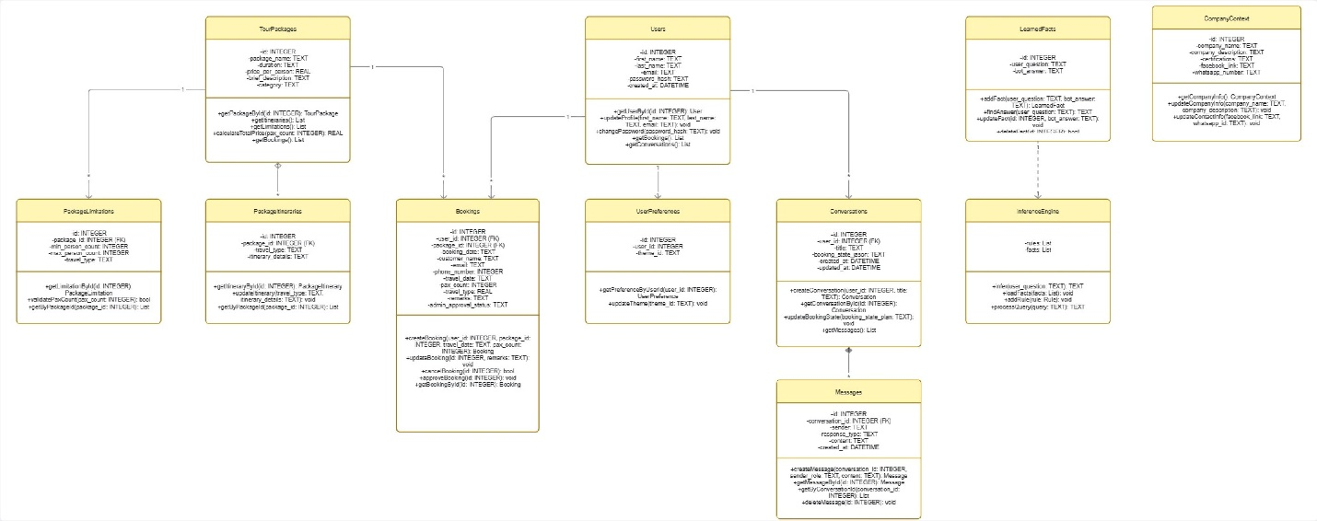
Figure 1: Class Diagram
The Class Diagram (Figure 1) serves as the architectural blueprint for the Nexus system's data layer, illustrating the static structure and behavioral logic of the application's core entities. It organizes the system into eleven distinct tables that handle everything from user identity and security to tour logistics and AI-driven knowledge acquisition. The diagram provides a technical overview by mapping out how various modules, such as the Inference Engine and Booking Flow, communicate with the SQLite relational database. By defining these classes and their internal methods, the diagram ensures that data remains consistent and structured throughout the software’s lifecycle. The relationships within the diagram are primarily centered around two main hubs: Users and TourPackages. The Users class is connected to several entities through one-to-many or one-to-one associations, serving as the primary key for Bookings, Conversations, and UserPreferences to ensure every recorded chat or reservation is linked to a verified identity. The TourPackages class functions as a parent entity for PackageItineraries and PackageLimitations, using foreign key constraints to link daily schedules and group size restrictions back to a specific travel product. Transactional and communication links are further defined through the Bookings class, which acts as a bridge between Users and TourPackages to track reservation details and administrative approval statuses. Similarly, the Conversations and Messages classes are linked to maintain a chronological history log of all interactions. On the cognitive layer, the LearnedFacts and InferenceEngine classes represent the system’s AI integration; LearnedFacts stores custom Q&A pairs, while the InferenceEngine utilizes these facts to process queries outside the standard pre-trained weights. Finally, the physical schema implementation utilizes ON DELETE CASCADE logic in tables like Messages and UserPreferences to ensure that if a user profile is removed, all related orphaned data is automatically cleaned to maintain database hygiene.

8. Natural Language Interface (NLI) Design
The Natural Language Interface (NLI) serves as the primary communication bridge between the human user and the underlying artificial intelligence. It consists of two main components: the visual frontend where users type their messages and view responses, and the initial text processing layer that cleans and prepares those messages before they are sent to the neural network. A well-designed NLI ensures that the system is visually engaging, easy to navigate, and capable of understanding user inputs accurately.

8.1. UI/UX Design (Frame-switching architecture using HTML/CSS)
The user interface (UI) of the Nexus chatbot is built as a modern Single Page Application (SPA) using HTML, JavaScript, and Tailwind CSS. Instead of relying on traditional, rigid desktop GUI libraries, the system utilizes the Python “Eel” library to bridge a web-based frontend with the Python backend. This approach allows for seamless, “frame-switching” architecture. When a user navigates between the main chat screen, the login portal, or their user profile, JavaScript dynamically hides and shows these HTML containers instantly without ever reloading the application window.
To enhance the user experience (UX), Tailwind CSS is used to implement a professional dark theme with responsive design rules. This ensures that the application layout, such as centering the login cards or stretching the chat history, automatically adjusts to look perfect regardless of the window size. Furthermore, the interface is designed to intelligently handle different types of data. Instead of just displaying plain text, the JavaScript frontend parses structured JSON responses from the Python backend and uses libraries like marked.js to render rich, formatted content, making tour information and booking summaries much easier for the user to read.

8.1.1. Initial Guest Portal
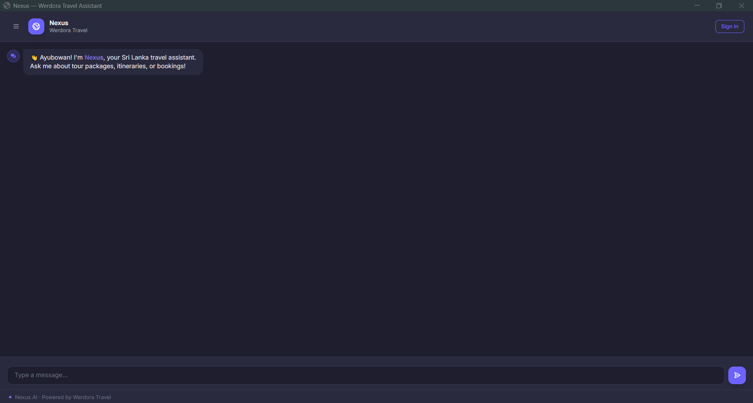
Figure 2: Initial Guest Portal

The Initial Guest Portal serves as the primary entry point for users upon launching the application. This interface allows visitors to engage in basic conversation with the virtual assistant before committing to an account, providing a welcoming greeting and introducing the bot’s core capabilities in tour packages and itineraries.

8.1.2. User Authentication Gateway
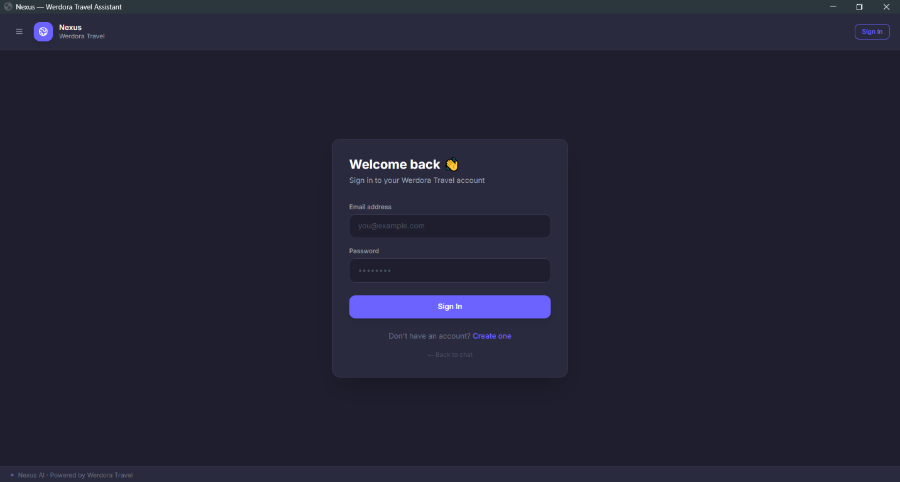
Figure 3: User Authentication Gateway

The User Authentication Gateway provides a secure centralized login form for returning travelers. This interface is designed with a clean, centered layout that focuses the user's attention on entering their email address and password, while also offering a direct link for new users to navigate to the account registration section.

8.1.3. Account Registration Interface
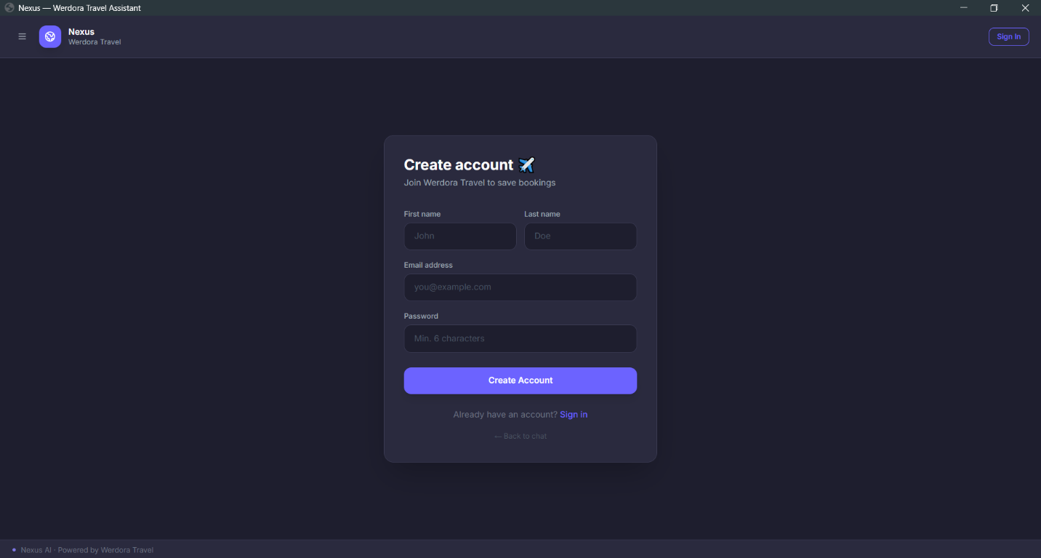
Figure 4: Account Registration Interface

The Account Registration Interface is a dedicated portal for new users to join the platform. It features a structured form that collects essential information including first name, last name, and email address, ensuring that all new profiles are established with the necessary data to facilitate future personalized bookings.

8.1.4. Authenticated Dashboard View
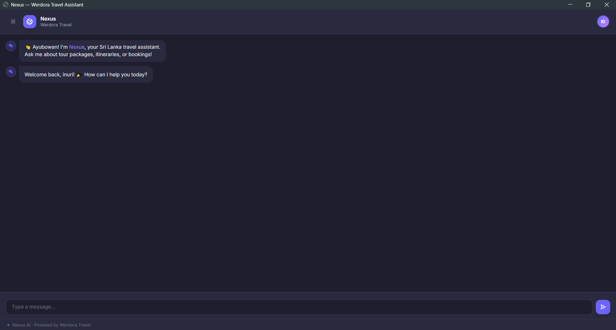
Figure 5: Authenticated Dashboard View

The Authenticated Dashboard View appears immediately after a successful login, greeting the user by name to create a personalized experience. This interface maintains a clean conversational space while enabling full access to advanced features such as saved chat history and personalized tour recommendations.

8.1.5. Interactive Reservation Workflow (Step 1)
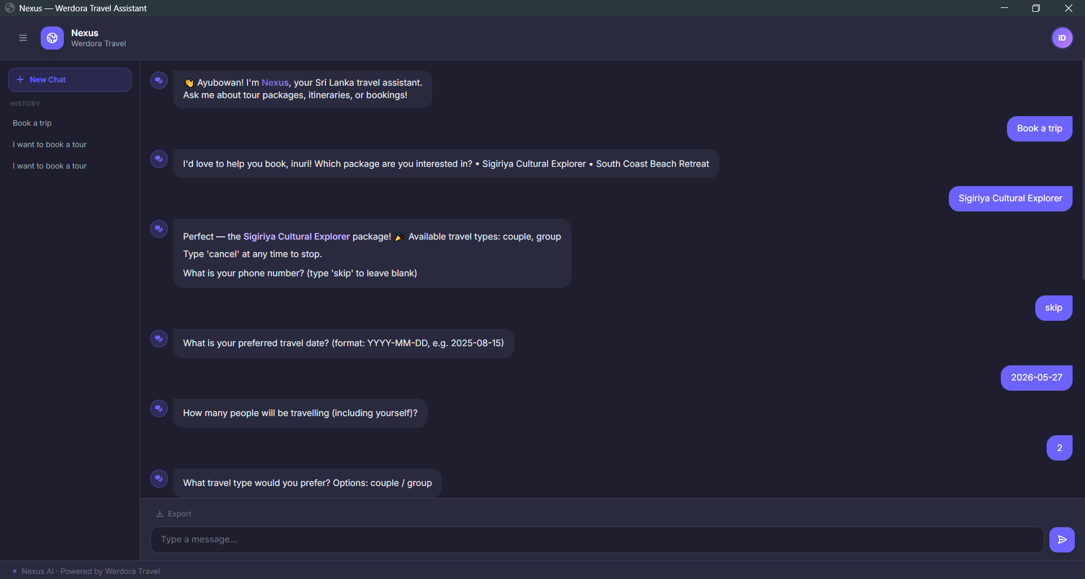
Figure 6: Interactive Reservation Workflow (Step 1)

The Interactive Reservation Workflow demonstrates the system's ability to replace static data entry with a dynamic, guided dialogue. In this phase, the bot systematically collects specific travel requirements, such as the selected tour package, preferred travel dates, and the total number of participants, ensuring all necessary data is gathered through friendly and responsive conversation.

6. Interactive Reservation Workflow (Step 2)
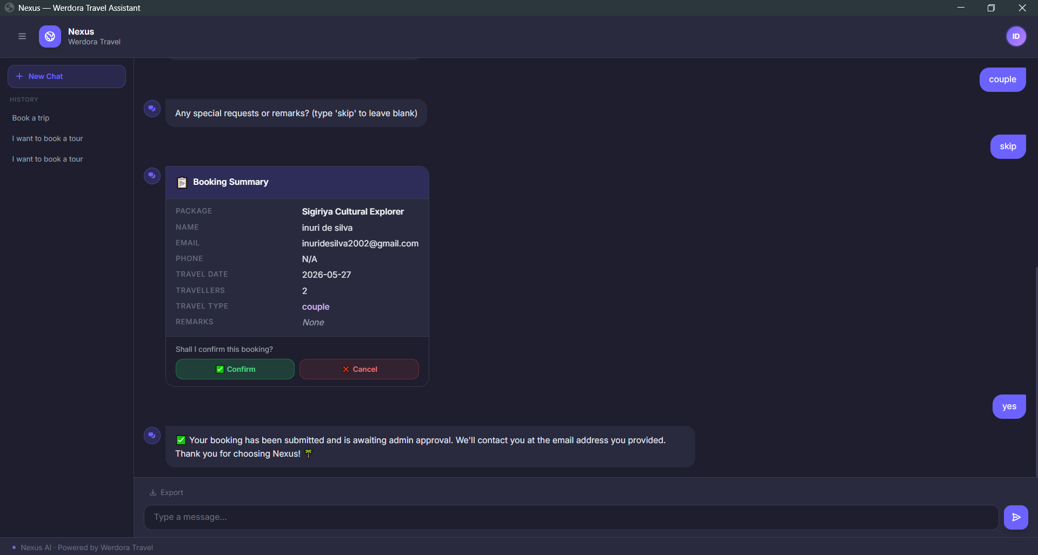
Figure 7: Interactive Reservation Workflow (Step 2)

The conclusion of the Interactive Reservation Workflow features the final validation and submission of the user’s request. The system generates a structured "Booking Summary" card to display all gathered data for a final accuracy check, allowing the user to confirm the details and submit the booking to the database for administrative review, successfully ending the transaction.

8.2. Text Processing and Normalization
Before artificial intelligence can understand what, a user is typing, the raw text must be cleaned and transformed into a format that a machine can read. Human language is naturally messy; users make typing mistakes, use different grammar tenses, and add unnecessary punctuation. To solve this, the Nexus chatbot uses the Natural Language Toolkit (NLTK) library to process the user's input in three specific steps: Tokenization, Lemmatization, and Vectorization (Bag-of-Words).
- The system performs Tokenization. This is the process of breaking down a complete sentence into individual words or “tokens.” For example, if a user types, “What are your tour packages?”, the tokenizer splits this into a list of separate words: [“What”, “are”, “your”, “tour”, “packages”, “?”]. This step isolates the key components of the sentence and removes extra spaces.
- The system applies Lemmatization. In English, the same word can be written in many ways depending on the tense (ex: “book”, “booking”, “booked”). If the neural network treats these as completely different words, it becomes inefficient. The lemmatizer analyzes the tokens and converts them back to their root dictionary form. For example, both “booking” and “booked” are reduced to the root word “book”, and plural words like “packages” are reduced to “package”. This greatly reduces the vocabulary size the system needs to memorize and improves the accuracy of the bot.
- The system uses the Bag-of-Words technique to convert these cleaned words into numbers. A PyTorch neural network cannot read English letters; it only understands math. The Bag-of-Words algorithm creates a large array (a list of zeros) representing every word the chatbot has ever been trained on. It then checks the user's lemmatized sentence against this list. If a word from user's sentence exists in the training vocabulary, the system changes the zero to a one in that specific position. This creates a numerical vector that represents the user's entire message, which is then passed into the neural network to determine their intent.

9. Inference Engine Reasoning and Processing
The Inference Engine is the most important intelligence layer of the Nexus Tourism Chatbot, which is the interface between the unstructured user input and the structured Knowledge Base. It uses an advanced 3-tier design in which the inference layer (Tier 2) is a PyTorch-based Neural Network with rule-based NLP logic to identify user intent and control the conversation.

9.1. Pattern Matching and Intent Recognition (PyTorch Neural Network)
The intent recognition system is based on a deep learning model that will be trained to serve as a user query classifier and will be defined by a set of defined categories that are specified in an intents.json file.

9.1.1. Neural Network Architecture
The system achieves the following structure of Feedforward Neural Network,
- Input Layer: Accepts a numerical vector (Bag of Words) containing the tokenized and lemmatized query typed in by the user.
- Hidden Layers: There are two fully connected (Linear) layers with ReLU (Rectified Linear Unit) activation functions to represent complex non-linear patterns in language.
- Output Layer: The last linear layer that returns raw scores (logits) of each possible intent tag.

9.1.2. NLP Pre-processing Pipeline
A sentence is first subjected to a series of transformations before being processed by the neural network,
- Tokenization: Splitting the raw string into words using the NLTK library.
- Lemmatization: Simplifying a word to its dictionary root (ex: traveling becomes travel) with WordNetLemmatizer.
- Vectorization (Bag of Words): The transformation of the lemmatized tokens into a binary array in which a 1.0 value would indicate the presence of a known vocabulary word and 0.0 would indicate the absence of a known vocabulary word.

9.1.3. Intent Tagging
This model is trained to identify certain tags which propel the specialized tasks of the chatbot,
- tour packages: Typical questions relating to available tours.
- inquire itinerary: Asks about day-by-day schedules.
- inquire-limitations: Inquiries about group sizes and types of travelers.
- book package: This is initiated by the multi-step conversational booking state machine.

9.2. Confidence Thresholds & Routing Logic
The engine does not just accept the maximum prediction of the model but will evaluate the statistical confidence of the outcome to be accurate and prevent hallucinations.
Table 1: Confidence Thresholds & Routing Logic
Threshold Level | Value | System Action
High Confidence | >=0.85 | The engine executes the command directly via dispatch_tag.
Medium Confidence | 0.60 - 0.84 | The system enters Clarification Mode, asking the user: “Did you mean [intent]?”.
Low Confidence | <= 0.60 | The system either enters Learning Mode or redirects to help topics.

9.2.1. Routing Decisions

- High Confidence Branch: If the probability meets the CONFIDENCE_HIGH threshold, the system calls specialized handlers like handle_inquire_packages or fetch_itinerary.

- Clarification Branch: If confidence is medium, the bot sets is_clarifying = True and waits for a “yes/no” response from the user before proceeding.

- Validation Gate: A high-priority check ensures input is valid (alphabetic characters) before running the model, preventing gibberish from triggering false intents.

10. Knowledge Base and Database Integration

A combination of a Knowledge Base and a Database makes sure that the chatbot is able to provide both personality-driven conversational answers and correct and updated business information.

10.1. Static Knowledge Management
Statics are managed by use of intents.json, which handles greetings, small talk and some frequently asked questions that need not be updated regularly.

- Standard Responses: A helper method, get_standard_response, gets a random response in the JSON file depending on a particular tag (e.g., “greetings”).
- Handling with Low Confidence: When the chatbot cannot make a prediction in high confidence, the chatbot enters learning mode.
- Learning Loop: The system requests the user to enter the correct answer and save it to a learned facts table in the database with save learned fact.
- Fuzzy Matching: To retrieve these user-taught answers the bot uses lookuplearnedfact with a fuzzy scoring algorithm.

10.2. Dynamic Data Retrieval

SQLite is used to handle dynamic data, and the bot can deliver up-to-date information on tour packages, itineraries, and booking restrictions.

10.2.1. Core Database Tables using dynamic data retrieval

The database design can address the needs of a broad variety of queries related to travelling,

- tour_packages: Stores the name, category, time span and the cost per person.
- package_itineraries: It includes day by day plans associated with certain types of travel.
- package limitations: The minimum and maximum number of people in each type of travel (ex: “couple” or “group”).
- company_context: Stores official company information such as social media links, and certifications.

10.2.2. Data Access Logic
The system involves special functions to retrieve and process this data to the user,
Table 2: Data Access Logics
Function | Purpose
fetch_tour_packages | Returns a list of all available tours for rich UI rendering.
fetch_package_detail | Retrieves specific pricing, descriptions, and travel types for a package.
fetch_itinerary_for_package | Pulls the detailed travel schedule based on the package name.
fetch_limitations_for_package | Checks group size constraints to ensure valid booking requests.

10.2.3. Intelligent Routing
To prevent the chatbot from trying to “learn” business-critical information, the system uses is_admin_data_query. If a user asks about pricing or schedules (keywords found in ADMIN_DATA_KEYWORDS), the bot suppresses the learning loop and directs the user to consult the official database records instead.

11. Machine Learning and Adaptive Training
The implementation of Machine Learning and Adaptive Training of the Nexus Tourism Chatbot is structured in two main constituents, namely, a Self-Learning Mechanism of the capturing of new knowledge and a Fuzzy Fact Retrieval system of a robust information recovery.

11.1. Self-Learning Mechanism
The self-learning logic enables the chatbot to expand its knowledge base independently whenever it receives questions that it is unable to answer through the neural network.

11.1.1. Fallback Logic & Learning Trigger
At a predefined threshold (ex: CONFIDENCE_MEDIUM = 0.60) when the confidence of the prediction given by the neural network falls below that threshold, the system enters a fallback branch,

- Admin-Managed Guard: This system initially examines the query to determine whether it contains keywords to do with tours, pricing, or company information (ex: price, itinerary). When it does, learning is inhibited to ensure that users do not contaminate important business information.
- Activation of Learning Mode: When the query is a general one, the bot goes into LearningState and asks the user the following: “I do not know how to answer that yet. I would like to know what the right answer is so that I can learn?”

11.1.2. Capturing User-Supplied Answers

When in is learning mode, the following user input would be received as the answer to the pending question.

- Storage: The couple is stored in the learned_facts table using save_learned_fact().
- Idempotency: In the case that the question already exists, the bot will update the record and will not create a duplicate.
- Cancellation: It is possible to write cancel or exit to cancel the learning process at any point.

11.2. Fuzzy Fact Retrieval
To make the bot resilient to typing mistakes and differences in phrasing, it uses fuzzy matching to find out information in the learned_facts and tour_packages tables.

11.2.1. Resilient Q&A Matching

A dedicated fuzzy score method is used to compare the user input with the stored questions.

Score = (0.55 × Jaccard Overlap) + (0.45 × SequenceMatcher Ratio)

- Jaccard Overlap: This is a measure of the overlap between the keywords in the input and those in the stored fact.
- SequenceMatcher: Compares the structure similarity of the character sequence.
- Thresholding: An item is only returned when the total score is above FUZZY_FACT_THRESHOLD (usually 0.72).

11.2.2. Fuzzy Package Resolution

To apply a substring bonus to the fuzzy score when there are meaningful keywords (ex: “safari” or “beach”) within a package name, the bot applies a substring bonus of 0.22 to the fuzzy score. This enables the bot to answer the question “Tell me about the safari” to the entire package of “Yala National Park Safari” without having to be an exact match.

12. Data Modeling and Schema Design
The system utilizes a relational database structure designed to support travel operations and an adaptive AI learning loop.

12.1. Database Tables and Relations
The chatbot_knowledge.db contains 11 tables that manage everything from core business logic to user-taught facts.
Table 3: Database Tables & Relationships
Table Name | Description | Key Relationships
users | Stores basic identity and authentication details. | Primary key for bookings, conversations, and user_preferences.
tour_packages | Contains core travel products, including duration and pricing. | Referenced by bookings, package_itineraries, and package_limitations.
bookings | Tracks package reservations and administrative approval status. | Connects users to specific tour_packages.
learned_facts | Stores custom Q&A pairs learned during user interactions. | Standalone table used for fuzzy-matched chatbot responses.
conversations | Groups individual messages into distinct chat sessions. | Links a user_id to multiple messages.
messages | Records the actual dialogue between the user and the bot. | Foreign key to conversations.
package_itineraries | Holds the detailed day-by-day travel schedules. | Foreign key to tour_packages.
package_limitations | Manages group size constraints (min/max pax) for packages. | Foreign key to tour_packages.
company_context | Stores official brand info like social media and contact details. | Metadata table for static brand inquiries.
user_preferences | Saves UI settings like theme choices (ex: dark mode). | One-to-one relationship with the users table.
sqlite_sequence | System-generated table managing autoincrementing primary keys. | Internal SQLite management.

12.2. Physical and Logical Schema.
The database is designed in a manner that it maximizes transactional integrity, and at the same time allows flexibility needed by an AI interface.

12.2.1. Logical Schema
The logical design is centered on a star-like schema with tour-packages and users being the main hubs.
- Operational Core: The interaction between users, tour packages and bookings constitutes the transactional core of the system which enables the bot to check the availability and record the intent.
- Knowledge Core: The learned_facts and company_context tables present a logical layer that the AI knows things about the world and the business without hard-coding information.
- Communication Layer: conversations and messages give a history log, so that the bot can keep track of the context in a session.

12.2.2. Physical Schema
The physical schema, which is implemented with SQLite, uses efficient data types to achieve high performance in a localized context. For example,
- Integrity Constraints: Using FOREIGN KEY constraints with ON delete CASCADE (in the messages and user prefers tables), the schema ensures that in the event of a user or a session being deleted, related orphaned data is automatically cleaned up.
- Data Types: It uses INTEGER as primary/foreign key, TEXT as descriptive content and state data in the form of a JSON, and REAL as a financial field, such as price_per_person.
- Automation: DATETIME fields are configured to default to (datetime('now')) to give automatic timestamps to messages and bookings without necessarily needing manual input on the application side.

13. Conversation and Dialogue Management
The Nexus Tourism Chatbot Conversational Flow and Dialogue Management system is designed to manage and process complex and multi-turn conversations using a strict state machine and a multi-layered validation engine.

13.1. Dialogue State Tracking (The Multi-Step State Machine)
The system uses a Finite State Machine (FSM) to control the non-linear conversations, tracking the progress of the user through the different service “scenarios” the system supports like booking a tour or requesting a refund.

13.1.1. Linear and Non-Linear Changes
The chatbot has a SessionState per user which determines how the bot will interpret the next input.
State Persistence
The state (ex: awaiting date, confirming guests) is stored in a session object, so that the bot is not forgotten of its context by the user asking a clarifying question half-way through the booking process.
The Booking Flow
- Selection State: The user has selected a package.
- Information Gathering State: A consecutive loop in which the bot solicits Name, Email, and Date.
- Validation State: The bot waits at every stage to ensure the input is valid before moving on to the next stage.
- Confirmation State: An ultimate report is displayed before the database is updated.
- State Reset: When the user gives an invalid response repeatedly or explicitly enters the state as restart, the state machine restarts itself to the idle or greeting state.

13.2. Input validation (Regex and Dynamic Constraints)
Authentication serves as a filter between the user interface and the data storage database, to ensure that dirty data is not introduced into the system.

13.2.1. Hard Validation (Pattern Matching)
Regular Expressions (Regex) are used in the system to provide strict formatting to the standardized data types,
- Email Validation: Makes sure the input is in the standard user@domain.com format.
Pattern: ^[a-zA-Z0-9+_.-]+@[a-zA-Z0-9.-]+$

- Date Formatting: Checks the date is entered in the format YYYY-MM-DD or DD/MM/YYYY.
- Phone Numbers: Checks numeric and local/international length specifications.
13.2.2. Dynamic Constraints (Soft Validation)
In addition to syntax, the bot has Logical Validation depending on the context at hand,
- Temporal Logic: When a user enters a date into a tour, the system will check whether the date is earlier than the date or whether the date is past the date or the 12-month booking window.
- Capacity Checks: In the case of the tour packages, the guest_count field is attempted to be checked against the max_capacity field in tour packages table.
- Error Correction: When a user types in the number of guests as Five rather than 5, then a numeric conversion utility is used to attempt to resolve the string to an integer and then fail the validation.

13.2.3. The Rejection Loop
In case of validation failure, the system will run a Graceful Retry logic,
- Identify Error: The bot describes what went wrong with the input (ex: the email address appears to be lacking an ‘@’ character).
- Reprompt: The state is not dormant, and the bot repeats the same question.
- Maximum Retries: Once a user has made three consecutive unsuccessful attempts, the bot will give the user one of the suggested example formats to follow.

14. Security and Privacy Protocols
The Security and Privacy Protocols to the Nexus Tourism Chatbot are aimed at securing user identity and ensuring integrity of personal travelling information by using industry-standard authentication and modern cryptographic techniques.

14.1. User Authentication
The system has an authentication layer that is highly secured so that only the authenticated users can perform sensitive operations like accessing the booking history or even finalizing a tour booking.

14.1.1. JSON Web Token (JWT) Implementation
The chatbot will be based on JWT (JSON Web Tokens) to manage stateless sessions.
- Token Generation: When a user successfully logs in, the server creates a token with the user_id, first name, and email that is signed with a unique SECRET_KEY.
- Session Expiration: Each token is coded with a 24-hour expiration (exp) to reduce potential threat of session hijacking.
- Token Decoding: The get-current-user(token) method will decode the JWT to ensure that the user is who he says before granting access to private data. In case the token is out of date or has been modified, the system will reject the request.

14.1.2. Authentication Logic
- Registration: Registers first name, last name, email and password. It has an integrity check which ensures that one email address does not have more than one account.
- Login Verification: Compares the email and password that the user provided with to the stored database information.
- Guest Access: As a “Guest,” the user can browse packages and ask general questions but will be prompted to sign in to access personalized capabilities.

14.2. Data Encryption
To safeguard sensitive credentials, the system strictly follows the principles of zero-knowledge storage of passwords, so that, even under the conditions of a database breach, the passwords stored in the system will not be readable.

14.2.1. Bcrypt Password Hashing
The chatbot uses the Bcrypt hashing algorithm that is specifically designed to be resilient to the brute-force attack.
- The salting: When registering, a special salt is created by bcrypt.gensalt() using a special salt. This salt is appended to the password and then hashed, so that attackers are not free to use precomputed rainbow tables.
- One-Way Hashing: Passwords are never written in plain text. They are changed into secure hash using bcrypt.hashpw() and stored in the database.
- Secure Comparison: When a user tries to get into the system, the system runs the following command to check the user: bcrypt.checkpw. This operation hashes the received password with the stored salt and compares it with the stored hash in a timing-safe fashion.

15. Testing and Performance Benchmarking
The Testing and Performance Benchmarking phase ensures the Nexus Tourism Chatbot is reliable, accurate, and resilient to unpredictable user behavior. This phase evaluates both the AI's cognitive ability (intent prediction) and the system's structural integrity (validation and error handling).

15.1. Accuracy and Recall Testing (Intent Prediction)
Accuracy testing measures how often the neural network correctly identifies the user's intent. Recall measures the system's ability to find and return all relevant instances of a specific intent.

Table 4: Intent Prediction Performance Testing
Test ID | Intent Tag | Input Sample | Expected Tag | Actual Tag | Confidence score | Result
ACC-01 | greeting | “Ayubowan, can you help me today?” | greeting | greeting | 1.00 | Pass
ACC-02 | book_package | “I'm ready to reserve my spot on a trip.” | book_package | book_package | 1.00 | Pass
ACC-03 | tour_packages | “What are the prices for your safaris?” | tour_packages | tour_packages | 1.00 | Pass
ACC-04 | company_info | “How do I get in touch with Nexus Travel?” | company_info | company_info | 0.86 | Pass
ACC-05 | goodbye | “That's all for now, talk to you later!” | goodbye | goodbye | 0.90 | Pass

15.2. Validation & Error Handling
This section focuses on Graceful Degradation, ensuring that when the bot fails (ex: due to low confidence or gibberish), it does not crash but instead guides the user back to a valid state.
Table 5: Validation & Error Handling Testing
Test ID | Scenario | Input / Condition | Expected System Behavior | Actual System Behavior | Status | Implementation Evidence
VAL-01 | Gibberish / Repeat Detection | User enters “zzzzzzzzz” | Reject input; detects identical characters exceeding the repeat threshold. | Input rejected as invalid. | Pass | is_valid_input in validator.py
VAL-02 | Past Date Prevention | User enters “2020-01-01” | Function compares input to current date and rejects dates in the past. | Blocked with “date provided is in the past.” | Pass | validate_booking_date in validator.py
VAL-03 | Fuzzy Package Matching | User asks for “safari tour” | SequenceMatcher and keyword overlap resolve “safari” to the correct package name. | Correctly resolves to the Safari package. | Pass | fuzzy_match_package in tour_handler.py
VAL-04 | Secure Password Storage | New user registration | The system must use bcrypt to hash the password before saving to the database. | Password hashed via bcrypt.hashpw. | Pass | register_user in auth_handler_6.py
VAL-05 | Session Security (JWT) | Authenticated user login | Generate a JSON Web Token with a 24-hour expiration (exp) payload. | Valid JWT token returned to user. | Pass | login_user in auth_handler.py
ERR-01 | Invalid Login Handling | Incorrect email or password provided | System catches failed match and returns False with an error message. | Returns “Invalid email or password.” | Pass | login_user in auth_handler.py
ERR-02 | Learning Loop Suppression | Query for “package cost” at low confidence | System identifies admin keywords and blocks the bot from asking the user for answers. | Returns “I’m not sure about that specific detail.” | Pass | is_admin_data_query in learning_handler.py

15.3. Unit Testing
Unit tests verify individual components of the system in isolation, such as utility functions and database queries.
Table 6: Unit Testing
Test ID | Component | Input | Expected Output | Actual Output | Status
UNIT-01 | validator.py | “2020-01-01” | (False, “The date provided is in the past. Please provide a valid future date.”) | (False, “The date provided is in the past. Please provide a valid future date.”) | Pass
UNIT-02 | validator.py | “not-a-date” | (False, “The date format is invalid. Please use YYYY-MM-DD (e.g. 2025-11-05).”) | (False, “The date format is invalid. Please use YYYY-MM-DD (e.g. 2025-11-05).”) | Pass
UNIT-03 | validator.py | “invalid-email” | False | False | Pass
UNIT-04 | validator.py | “2026-12-25” | (True, None) | (True, None) | Pass
UNIT-05 | main.py | “user@example.com” | True (Match) | True | Pass
UNIT-06 | auth_handler.py | (“Namal”, “Perera”, “namal@mail.com”, “pass123”) | (True, “Registration successful!...”) | (True, “Registration successful!...”) | Pass
UNIT-07 | tour_handler.py | “safari tour” | “South Coast Safari” | “South Coast Safari” | Pass
UNIT-08 | learning_handler.py | “cancel” | (“No problem!...”, LearningState(is_learning=False)) | (“No problem!...”, LearningState(is_learning=False)) | Pass

15.4. System Testing

This will provide a breakdown of the end-to-end test cases for the Nexus chatbot, including user journeys that involve interacting with both the frontend UI and backend database and state management logic.

Table 7: System Testing
Test ID | Component | Input | Expected Output | Actual Output | Status | Evidence
SYS-01 | Registration | Valid user details (Name, Email, Password) | User profile created and redirected to Login screen. | Account successfully stored in database and UI updated. | Pass | users.db record / UI Success Message
SYS-02 | Login | Registered email and matching password | Access granted to the main chatbot interface. | Chat UI loads session for the specific user. | Pass | Dashboard Screenshot
SYS-03 | Booking Info | Valid date and number of travelers | System accepts inputs and proceeds to travel type choice. | Data persists accurately through the multi-step form. | Pass | UI Flow Sequence
SYS-04 | Booking Flow | 2 travelers, valid date, confirm selection | Final confirmation message with summarized details. | “Your booking for South Coast Safari is confirmed...” | Pass | Confirmation
SYS-05 | State Manager | User sends “cancel” during active booking | Current session state is cleared and user is returned to main menu. | “Booking cancelled. How else can I help?” | Pass | Bot reply
SYS-06 | Error Handling | Entering an invalid email format during login | UI displays a validation error message. | “Please enter a valid email address” appears in red. | Pass | UI Error Label
SYS-07 | Knowledge Base | “Who am I?” | Bot retrieves info from the database. | Relevant user details displayed. | Pass | User details
SYS-08 | Logout | Clicking “Sign out” button | Session ends and user is redirected to the Landing page. | Database session cleared and UI returns to login. | Pass | UI Navigation Log
SYS-09 | UI Customization | Toggling between UI themes | Interface theme colors change across all components. | CSS variables updated and theme preference saved. | Pass | UI Comparison Screenshots

16. User Manual and Operational Guide

This is the complete Setup, Installation and Guided Tour of the Nexus Chatbot system.

16.1. Installation and Setup

The Nexus Chatbot requires certain technical requirements to function properly and a step-by-step installation procedure.

16.1.1 System Requirements

- Supported operating systems: Windows 10/11, macOS 12+ or a recent Linux distribution (Ubuntu 22.04 is recommended).

- The host machine needs to have python3.10 or above installed.

- Memory: At least 4 Gb of ram for smoother PyTorch model inference.

- Storage: 500MB free space to store project files, SQLite databases and neural network weight files.

- Internet connection: This is needed when installing the package for the first time to download the NLTK datasets and Python dependencies.

Create a repository clone and prepare environment. Prepare environment and do repository cloning. To prepare the local environment, follow these steps:

- Step 1: Launch terminal or command prompt.

- Step 2: Clone the project repository from GitHub using the following command,
Project Repository: )
git clone [https://github.com/](https://github.com/)[your-repo-link]/Nexus-bot.git

- Step 3: Change directory into the project directory: cd nexus-bot

- Step 4: Identify dependencies and isolate them with virtual environment. Create a virtual environment with python -m venv .venv

- Step 5: Start the virtual environment. On Windows, activate by running .venv\Scripts\activate. On macOS/Linux, execute the command source .venv/bin/activate.

- Step 6: Install the following Python packages. To install the required packages, use pip install -r requirements.txt.

- Step 7: Install the CustomTkinter library that is used exclusively in the GUI: pip install customtkinter

This is used to initialize the database and model. It is used to initialize the database and model.
The data layers need to be initialized before the bot is deployed,

- Initialize Database: Run the setup script to create the SQLite schema and seed tour packages: python database/db_setup.py

- Install NLTK Data: NLTK requires some corpora for text processing, these can be pre-installed: Download the NLTK resources you need to use the program with the following commands: python -c “import nltk; nltk.download('punkt'); nltk.download('wordnet'); nltk.download(‘omw-1.4’)”

- Train the Neural Network: Create the data.pth model file by training on the intents: python train.py

16.2. User Interaction Flow

Nexus has a dual mode of interaction. Users can interact either through a traditional terminal interface or through the current Graphical User Interface (GUI).

16.2.1. Launching the Application

- Run: GUI Mode (Recommended) - start up the modern interface: python controller.py

- Console Mode: Run: to launch the console version of the program (text mode): python main.py

16.2.2. Guest Browsing vs authenticated booking
Access levels are managed to ensure the integrity of the booking and protection of user data.

Guest User Capabilities

- Package Browsing: Members can inquire about the tours available like “What beach tours do you have?” or “Show me safari packages.”

- General Inquiries: Guests may inquire about general information about the company, general tips for travel to Sri Lanka or the weather.

- Knowledge Base Search: Get information about particular landmarks such as Sigiriya or Ella.
(Add UI Interface 2: Guest Chatting and Tour Package Display)

Authenticated User Journey (The Booking Process)
The user must go through the authenticated workflow to book a tour:

- Registration: Users are required to sign up by using the Sign-Up screen from the website using their valid email ID and password.

- Login: Log in the registered account and access the booking engine.

- Initiating a Booking: To start an automated flow to initiate a booking, use a phrase such as: “I want to book a trip” or “Confirm a tour”.

- Data Collection: The bot will systematically request travel date (YYYY-MM-DD), number of travelers, and preferred type of travel.

- Validation: Date will be automatically verified, and the format of the e-mail will be checked.

- Confirmation: The booking is written to the bookings.db file and success message is shown.
(Add UI Interface 3: Authenticated Booking Form and Success Modal)

16.2.3. Learning Hub Interaction

Nexus is designed to be user driven.

- Teaching the Bot: If the Bot doesn't know an answer, it will invite the user to fill in information.

- Fact Storage: After a user gives a factual answer, the bot writes this to the learned_facts table.

- Verification: Future users of the system will get this answer from previous sessions when they ask the same question.

(Add UI Interface 4: Learning Hub Prompt and Fact Submission)

16.2.4. UI Customization and Exit
- Theme Switching: Switching between color modes is done with the switch in the upper right corner of the GUI.

- Safe Exit: Use the “Logout” button or type “quit” to ensure that session data is managed appropriately before session is closed.
(Add UI Interface 5: Theme Switcher & Settings Menu)

17. Individual Contribution Report

18. Future enhancements and scalability
In order to make the Nexus chatbot useful to the general public and not just an academic exercise, some improvements are in the works. The improvements are aimed at augmenting the intelligence of the model, expanding the user interface, and adapting the back end to cope with an increasing number of users.

18.1. Technical & AI Enhancements
The bot's intelligence will be enhanced to process more complex human language and offer greater personalization.

- API integration with Large Language Models (LLMs): Moving from the existing intent classifier (based on PyTorch) to a fine-tuned LLM (such as GPT-4 or Gemini) using integration. This will enable more natural and flowing conversation and will enable multi-turn queries even if the keywords are not matched.
- Multilingual Support: Extension of the nltk_utils and training datasets to add support for Sinhala and Tamil. This will enable the bot to better respond to the needs of local residents and tourists from foreign countries.
- Voice Recognition and Synthesis: Combining Speech-to-Text (STT) and Text-to-Speech (TTS) to enable users to interact with Nexus hands-free as they travel.
- Sentiment Analysis: Integrating sentiment analysis to identify user frustration or excitement and automatically changing the tone of the bot or transferring more complex queries to a human agent.

16.2. Functional & Feature Upgrades
New features will be added to enable the tourist to have the “one-shop” experience in Sri Lanka.

- Real-time API Integrations: Integrating the tour_handler with outside APIs to track flights in real-time, provide up-to-date weather data at specific places, and get real-time currency conversion data.
- Payment Gateway Integration: Beyond “Pending” booking statuses with Stripe or Helcim payment gateways integration. This would enable users to make payment for their tour deposits directly from Chat UI.
- Interactive Mapping: A Map interface which is embedded in the GUI that visually plots out the package_itineraries table, depicting the travel route across Sri Lanka.
- Dynamic Pricing Engine: Upgrading the database/chatbot_knowledge.db to adapt to seasonal pricing, which automatically adjusts the price based on peak and off-peak travel months.

16.3. Scalability & Infrastructure
The infrastructure will be scaled to high availability and performance as the user base expands and put on the cloud.

- Cloud Migration (AWS/Azure): Deploying the SQLite database and Python backend to cloud instances, enabling them to scale vertically and horizontally during busy tourist seasons.
- Move to PostgreSQL: Switching from SQLite to a stable, robust and powerful relational database management system to manage thousands of concurrent booking transactions and user sessions.
- Mobile Application Development: Packaging the gui.py logic to create a cross-platform mobile app using frameworks such as Kivy or Flutter, enabling Nexus to be used on an iOS and Android device.
- Admin Dashboard: A web-based admin dashboard to provide a way for travel agents to edit intents.json and package data without having to touch the raw source code or manual seed files.

References

Ivanov, S.H. and Webster, C. (2019). Robots, Artificial Intelligence, and Service Automation in Travel, Tourism and Hospitality. Emerald Publishing Limited. doi: https://doi.org/10.1108/9781787566873.

Sommerville, I. (2016). Software Engineering Tenth Edition. [online] Available at: https://dn790001.ca.archive.org/0/items/bme-vik-konyvek/Software%20Engineering%20-%20Ian%20Sommerville.pdf.

Whitten, J.L. and Bentley, L.D. (2005). Systems Analysis and Design Methods. McGraw-Hill/Irwin.

